- Launch one EC2 using Amazon Linux 2 image and add a script in user data to install Apache.
Step 1: Login to your AWS account as root user and select EC2 Launch instance and select the configurations to launch an instance.
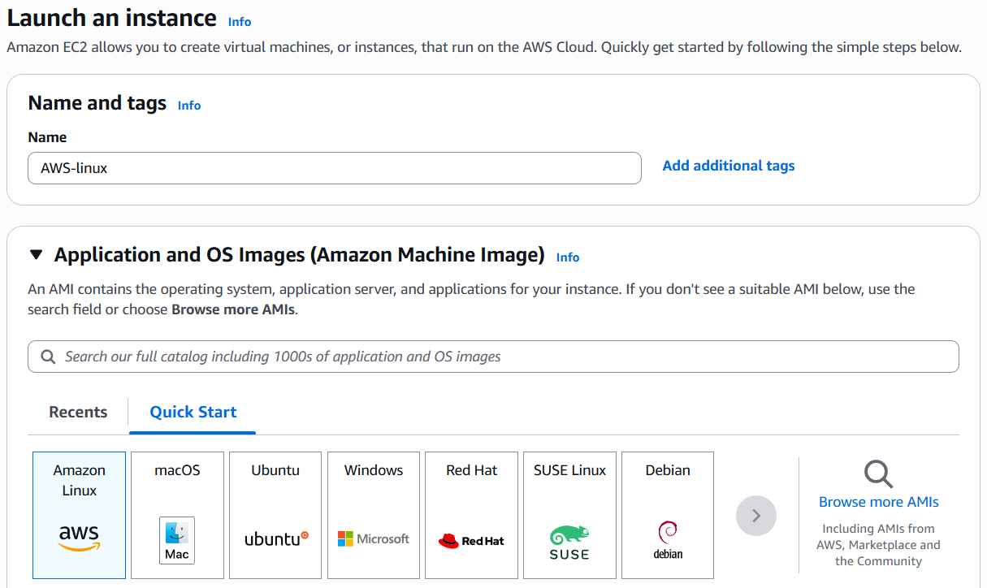
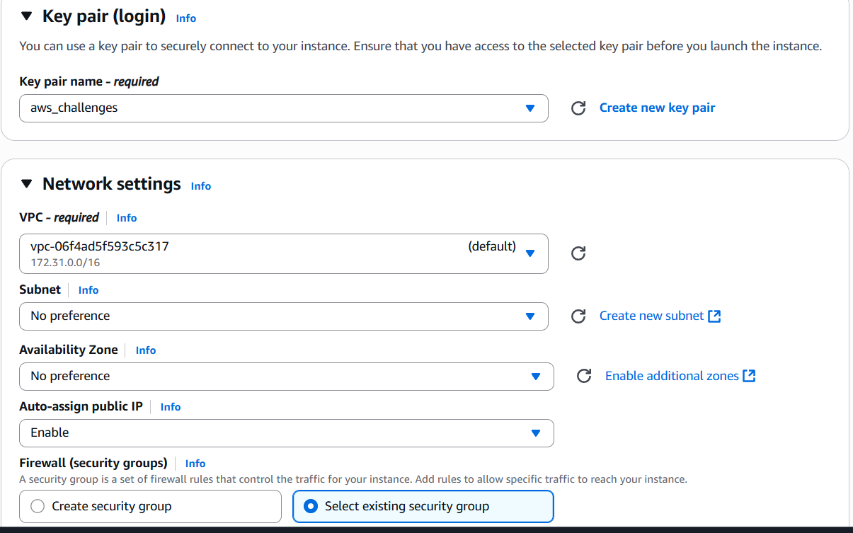

Step 2: Add the script in user data section to install apache and click launch instance.
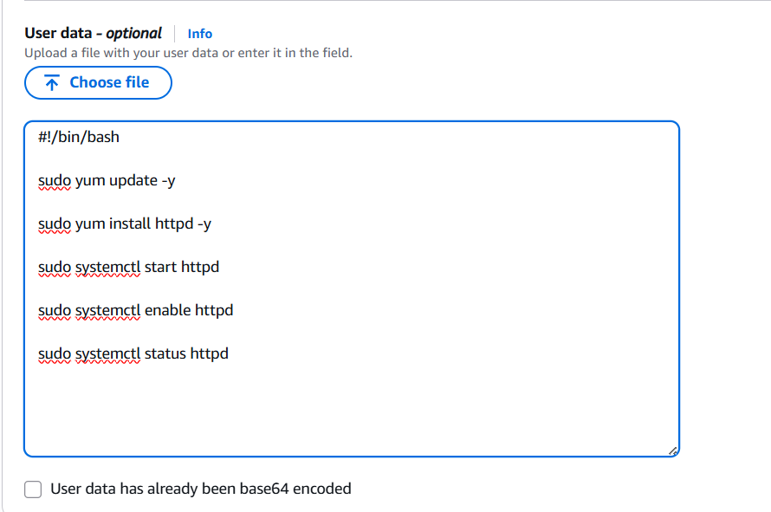
Step 3: Verify it by connecting to ec2 server.
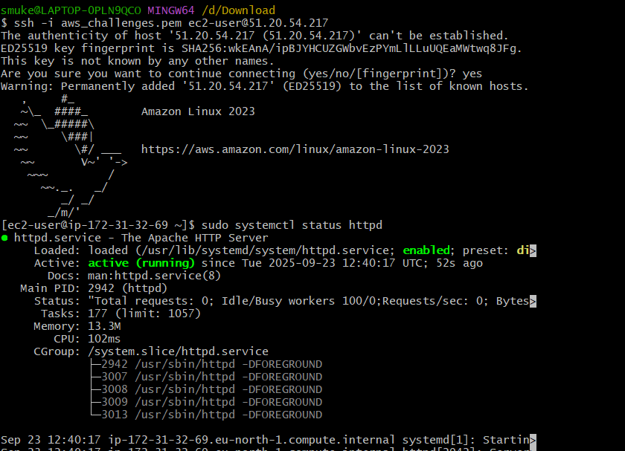
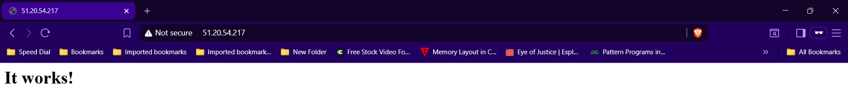

- Launch one EC2 using Ubuntu image and add a script in user data to install Nginx.
Step 1: Login to your AWS account as root user and select EC2 Launch instance and select the configurations to launch an instance.
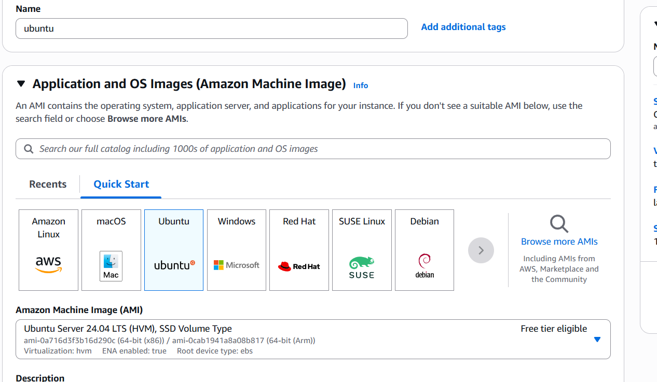
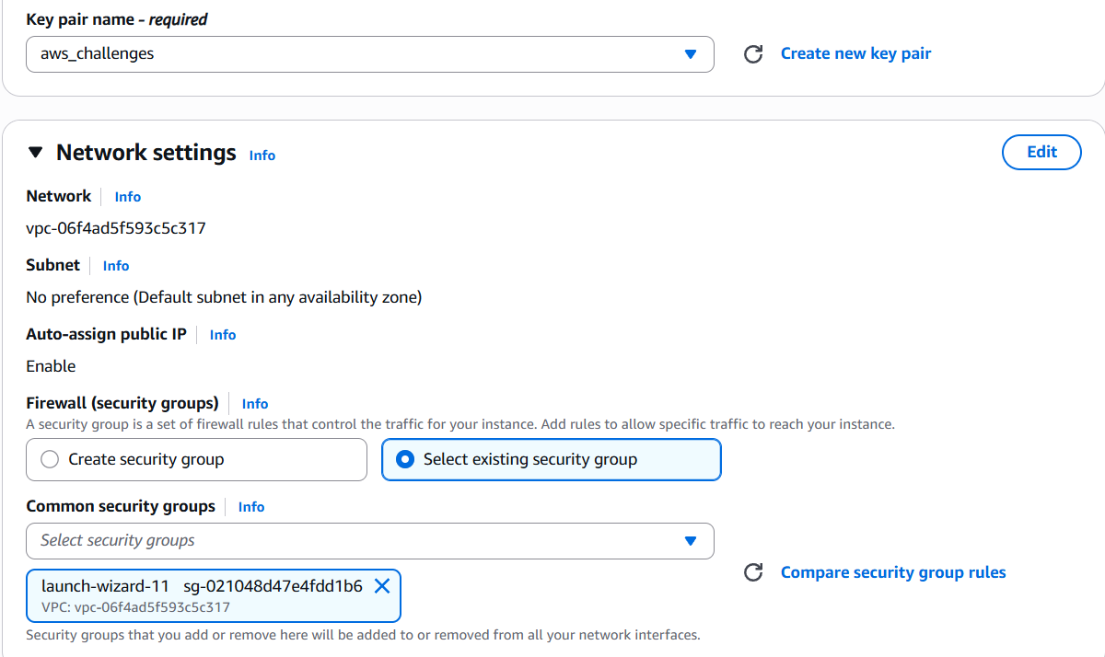

Step 2: Add the script in user data section to install nginx and click Launch instance.
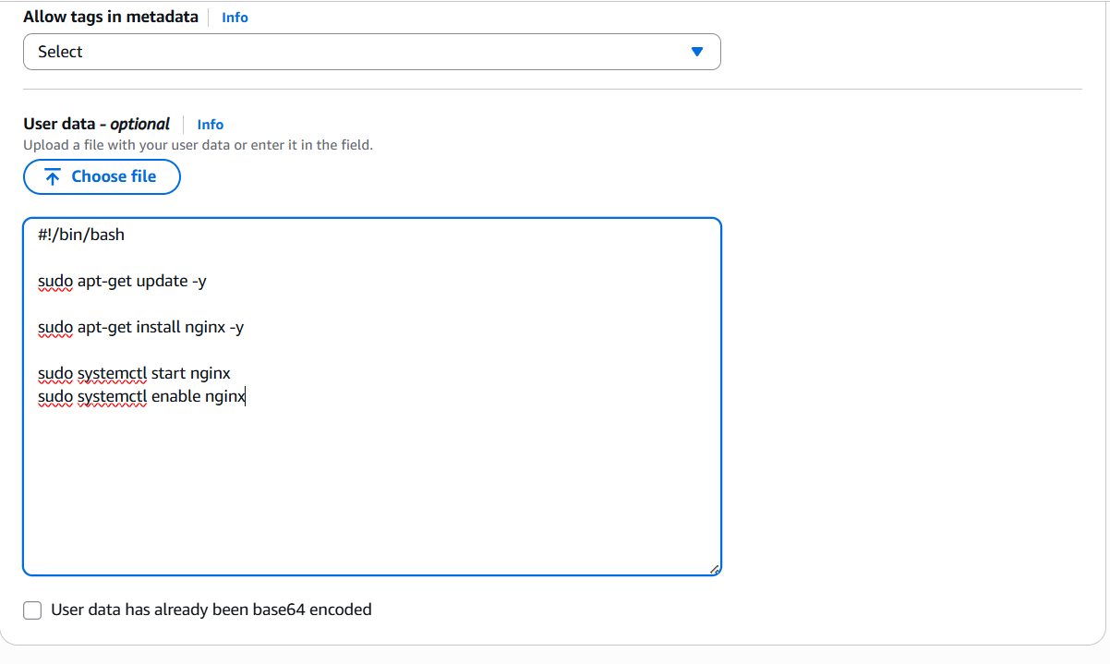
Step 3: Verify it by connecting to ec2 server.
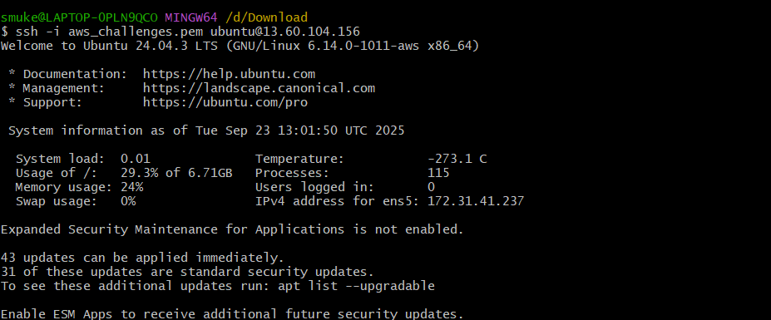
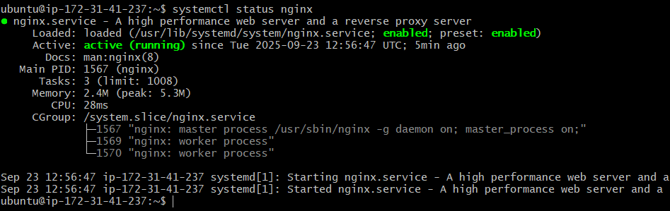

- Launch one Windows server and install Tomcat on Windows.
Step 1: Login to your AWS account as root user and select EC2 Launch instance and select the configurations to launch an instance.
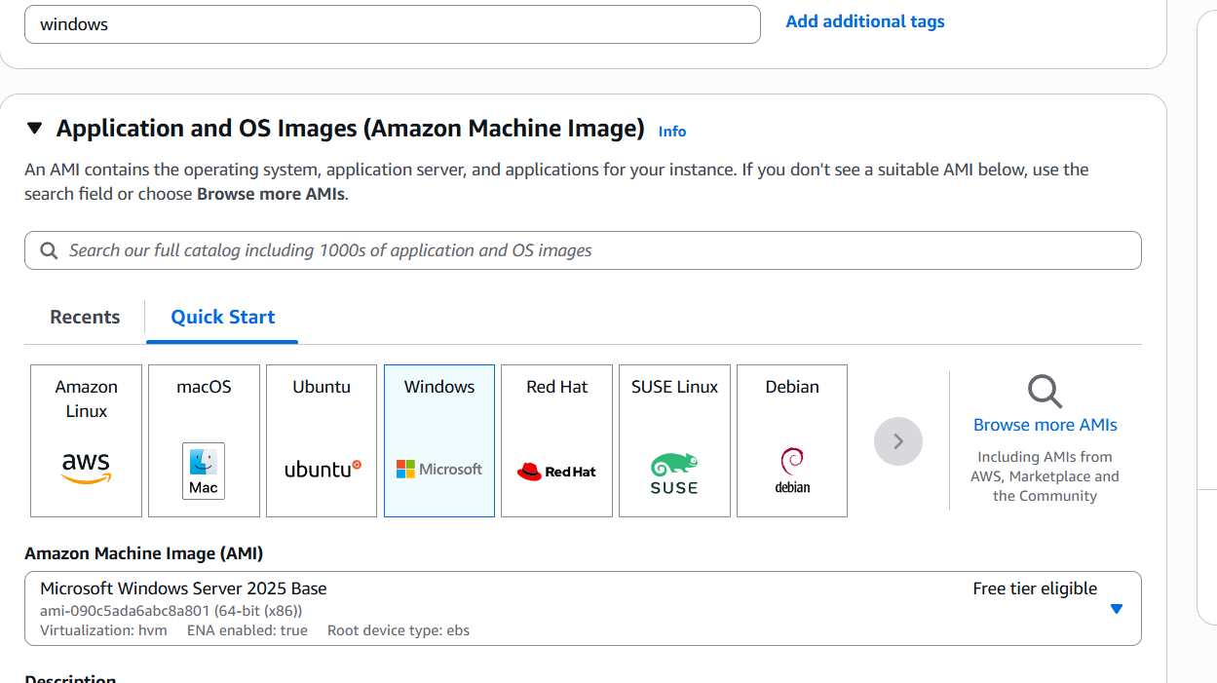

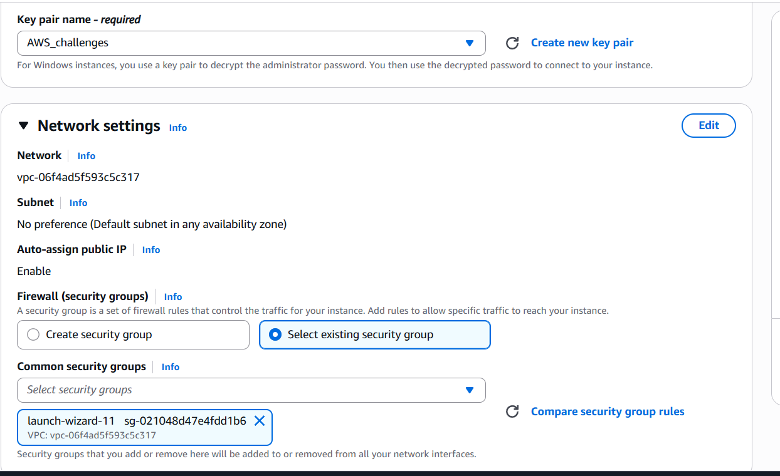
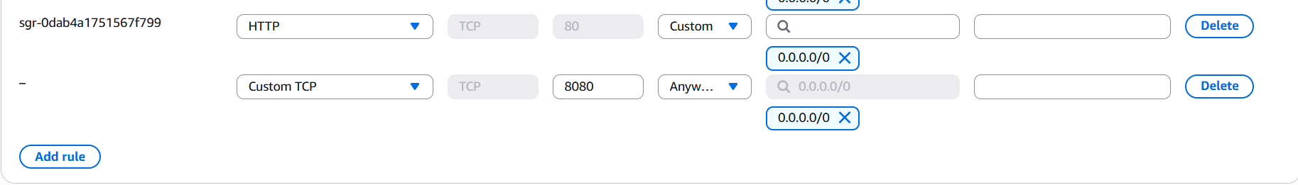

Step 2: Download and install Apache tomcat windows service installer and remote desktop.
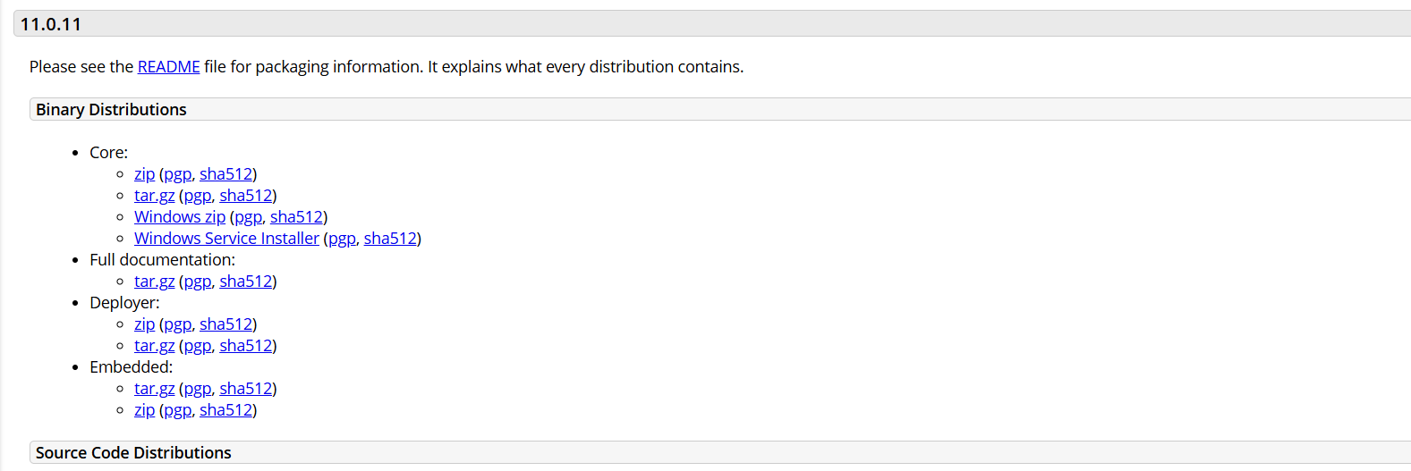
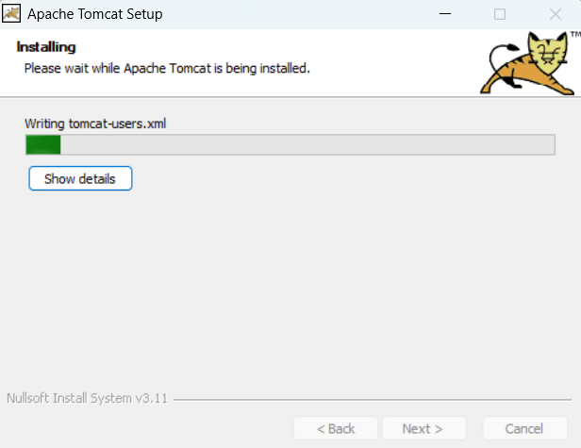
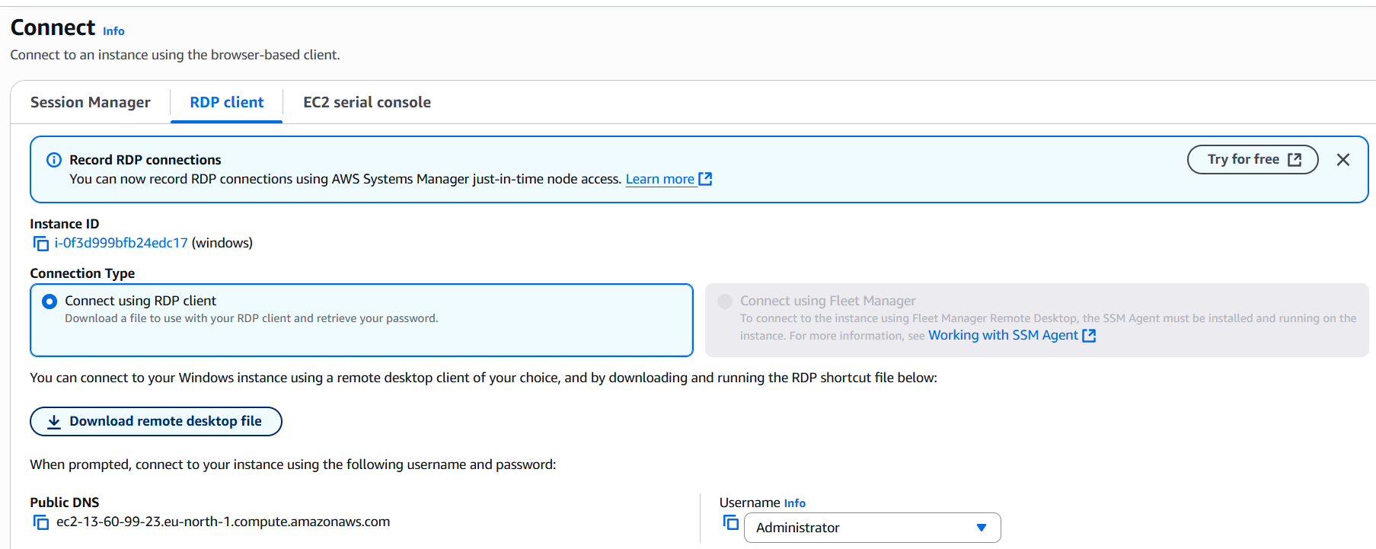
Step 3: Connect to the remote desktop and install java and apache tomcat.
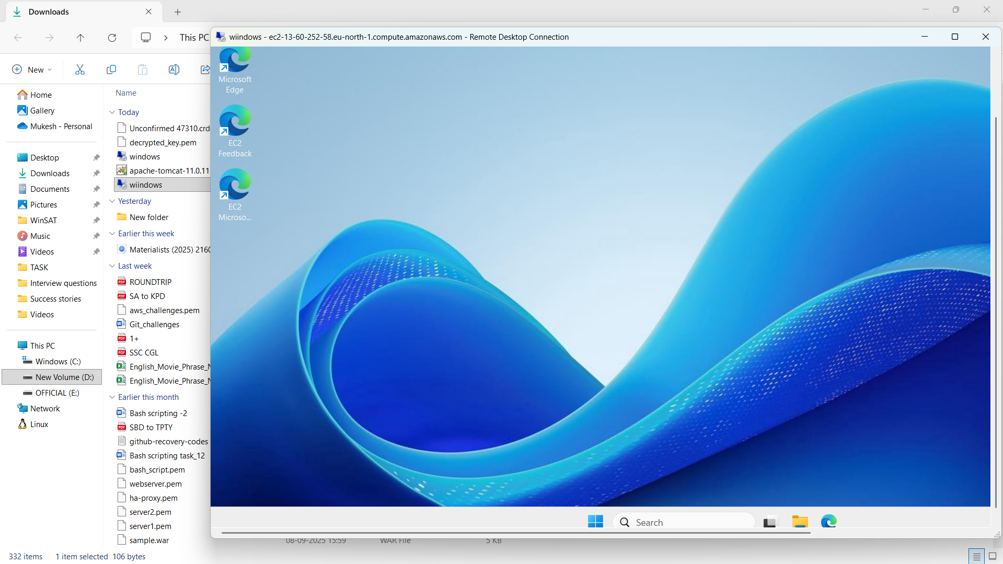
Step 4: Run localhost:8080 in browser.
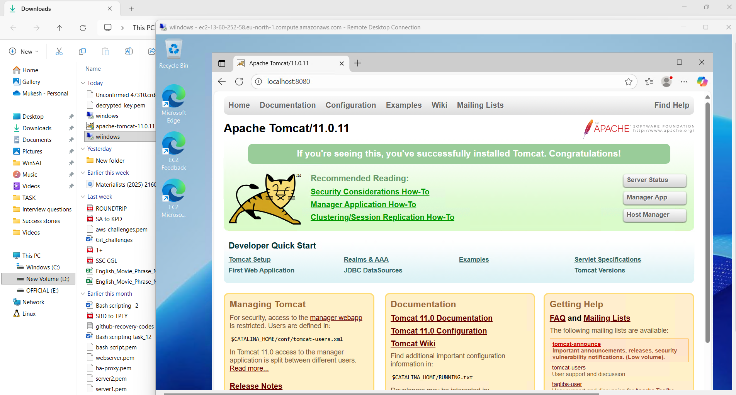

- Take a snapshot of the instance created in Task 1.
Step 1: Select the instance to take snapshot and select volume in storage section.
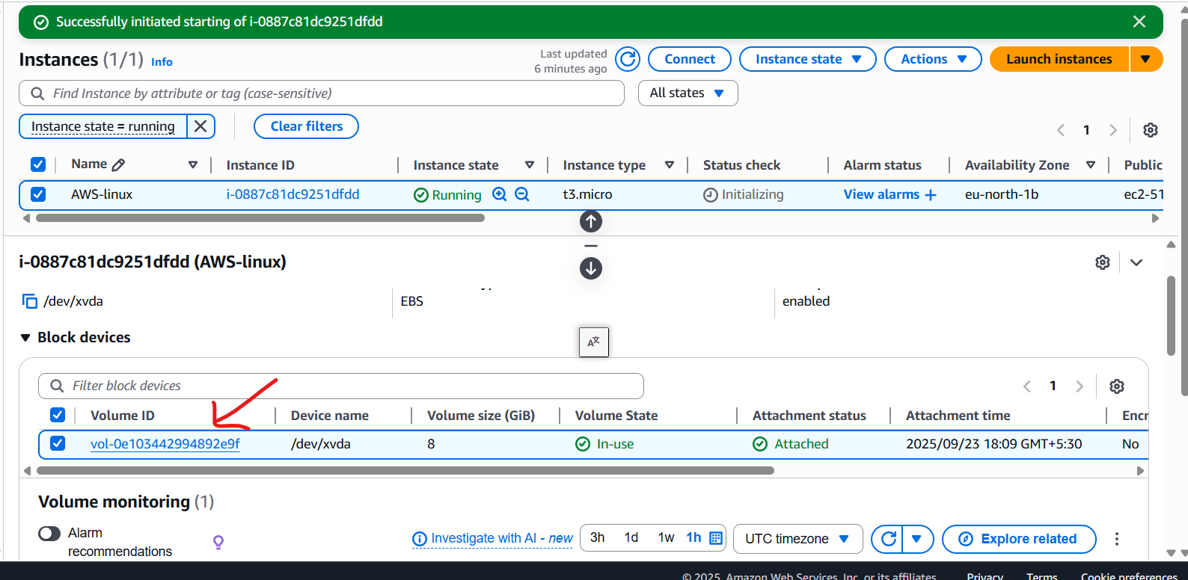

Step 2: Select the volume to take snapshot and click Action create snapshot.
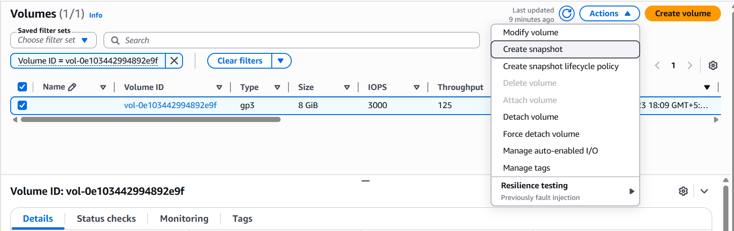
Step 3: Give snapshot description and select create snapshot.
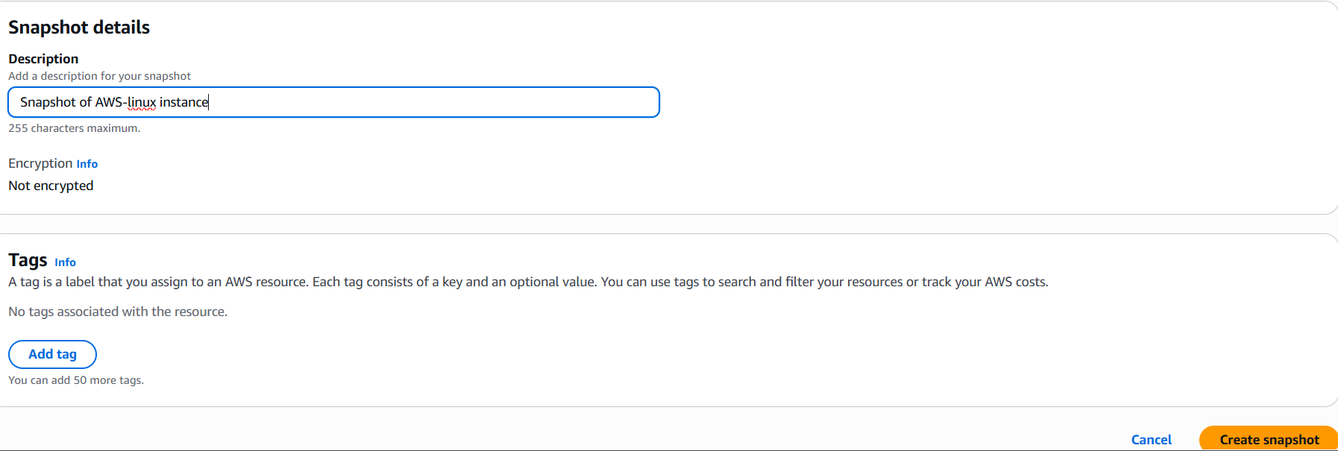
Step 4: Verify it in snapshot section under Elastic Block Store.
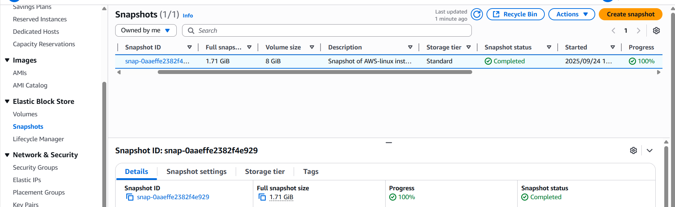

- Assign passwordless authentication for the EC2 created in Task 2.
Step 1: Create a public key using ssh-keygen command and copy it.
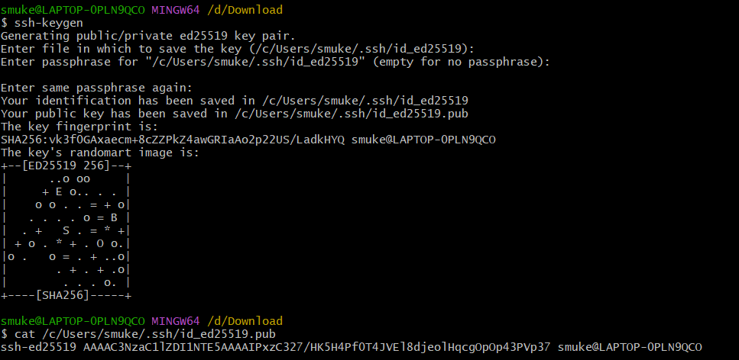
Step 2: Login to the instance and paste the public key in authorized_keys file and save it.
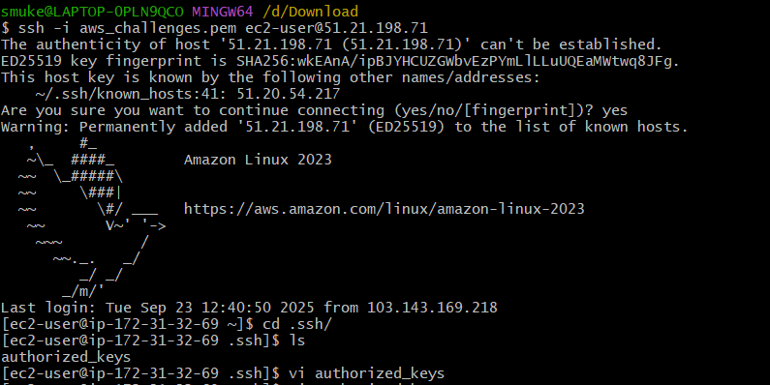
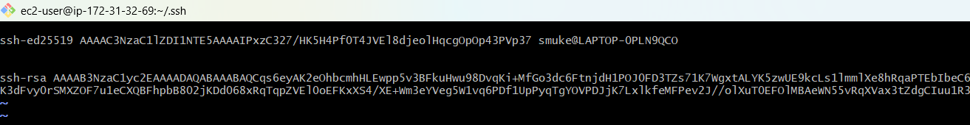
Step 3: Now login using ssh user_name@public_ip.
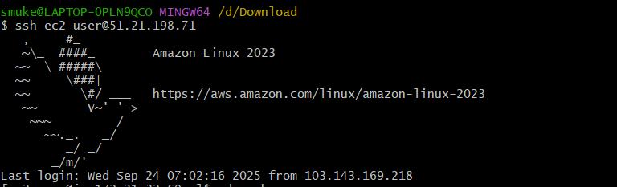
- Launch any EC2 using the spot purchasing option.
Step 1: Select the required configurations and select spot instance customise spot instance under purchasing option.
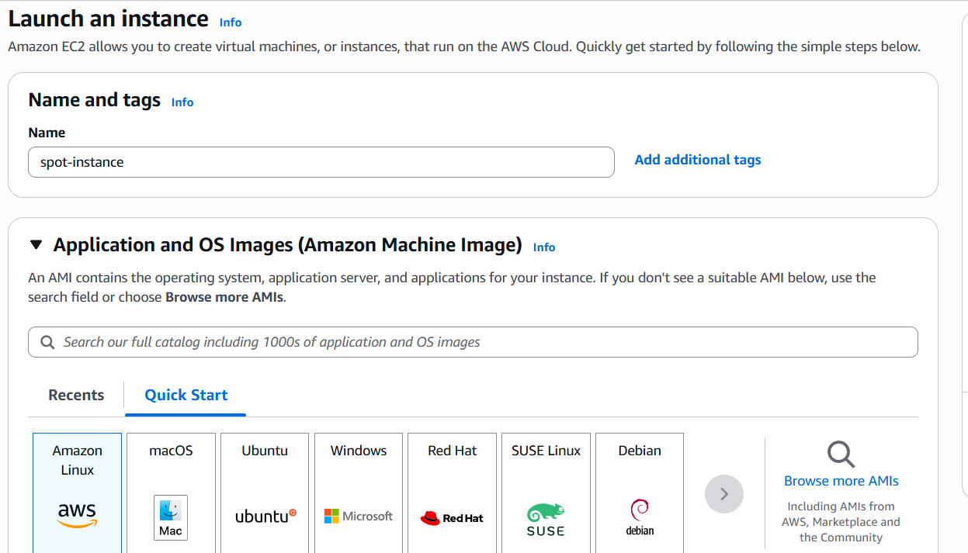
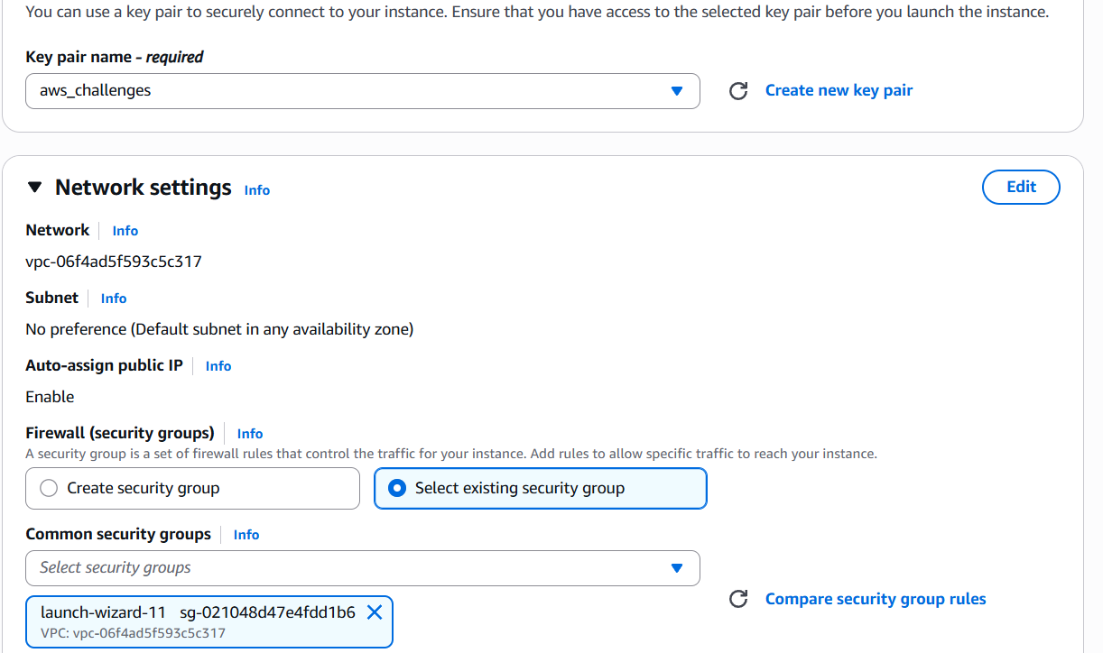

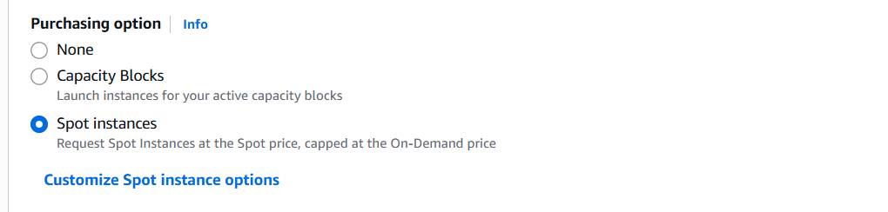
Step 2: Set maximum price and select Request type and Interruption behaviour and launch instance.
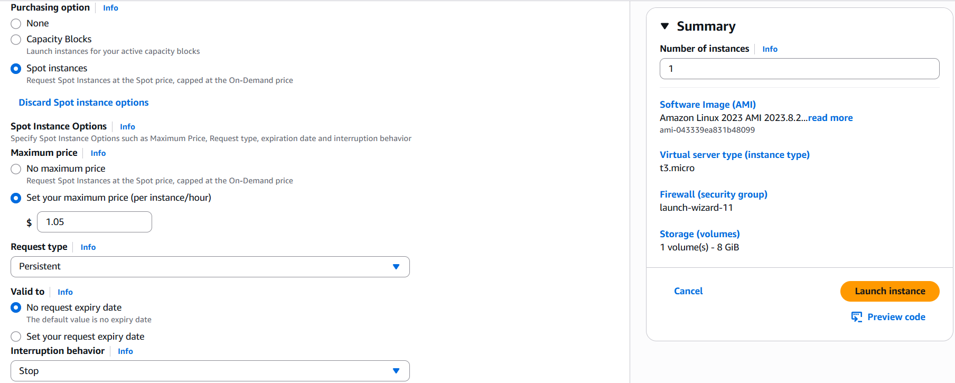
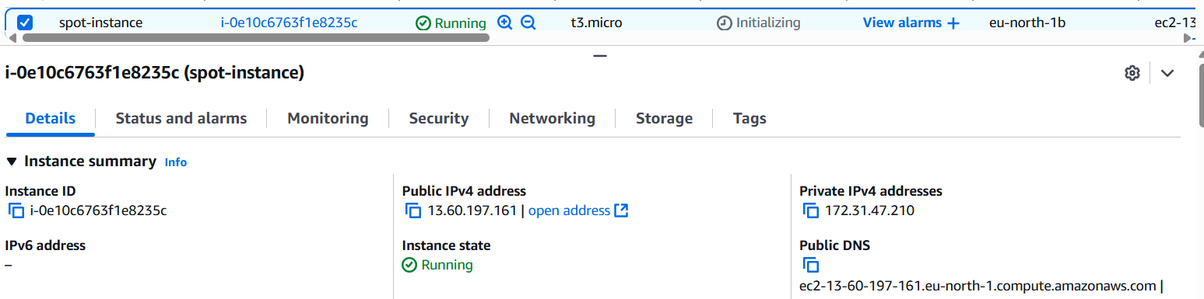

- Enable termination policy on the EC2 created in Task 2.
Step 1:Select the instance and select instance settings change termination protection under Actions menu.
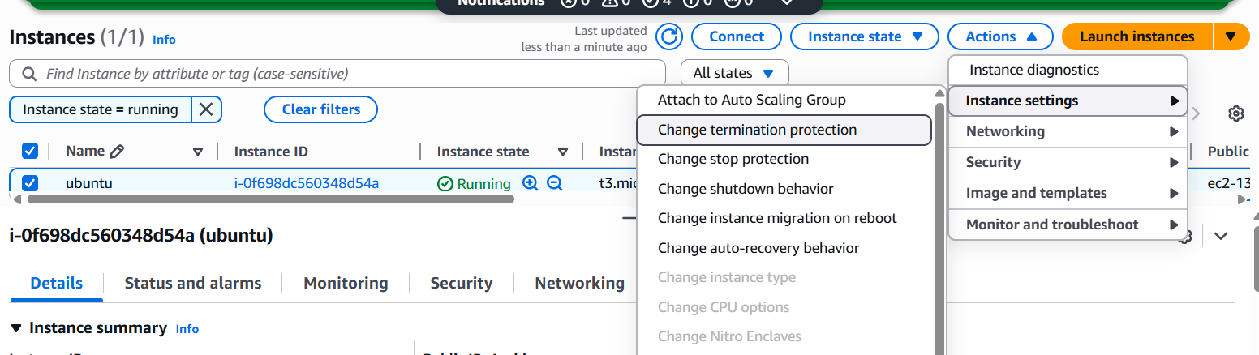
Step 2: Select Enable and save it.
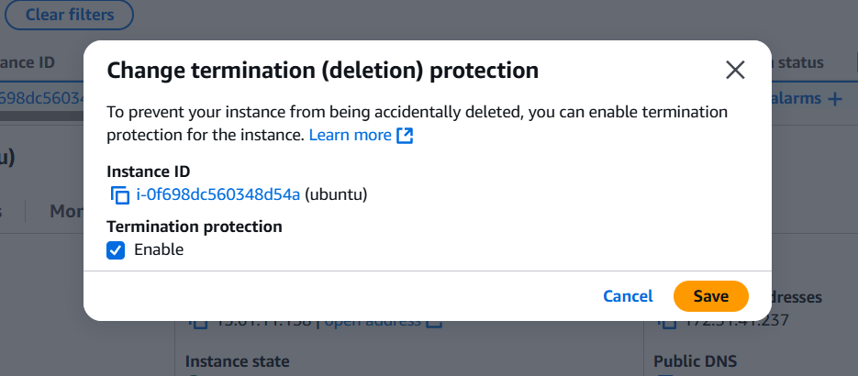
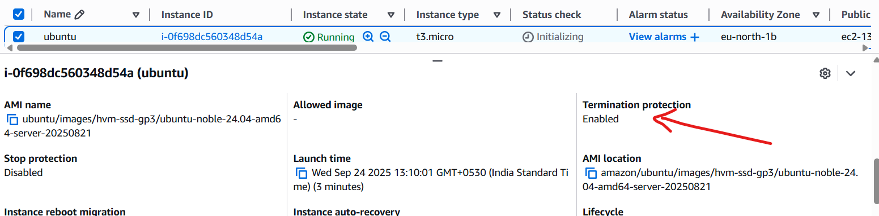

- Launch one EC2 using AWS CLI.
Step 1: Download and install the aws cli.
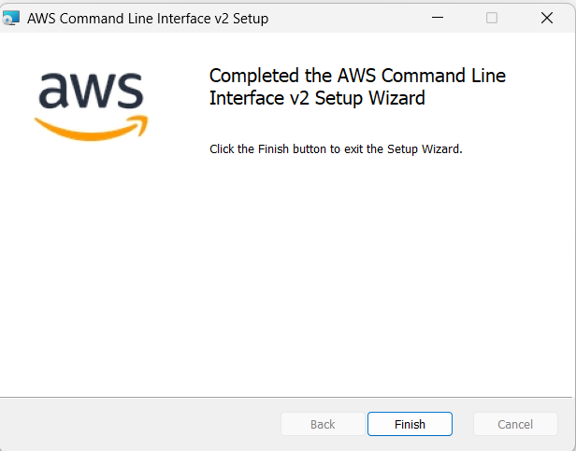
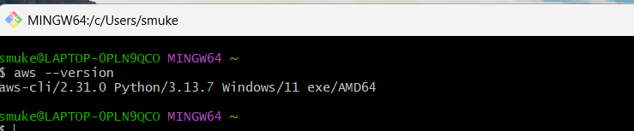

Step 2: Login to your aws console select IAM My security credentials Create access key
and copy access keys.
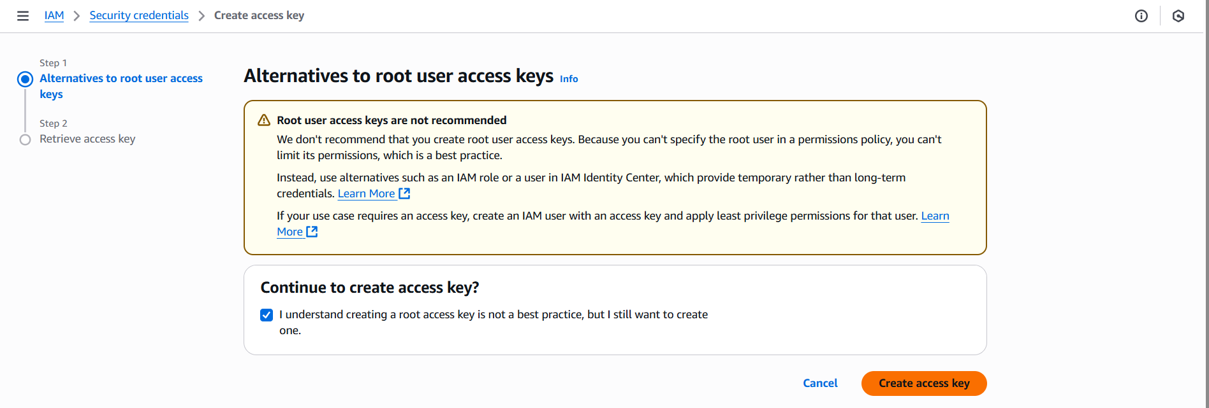
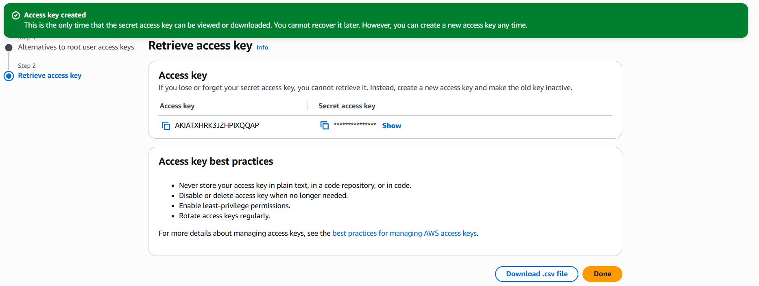
Step 3: Configure aws using aws configure command.
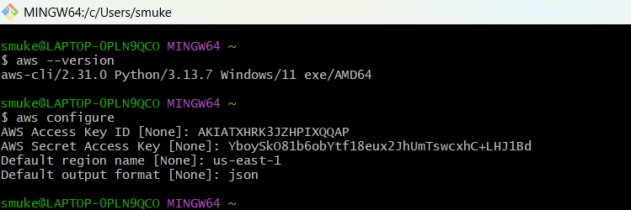
Step 4: Run aws ec2 run-instances --image-id ami-03657b56516ab7912 --count 1 --instance-type t2.micro --key-name oct2020 --security-group-ids sg-0158ed0df68ca337c --subnet-id subnet-3edf3f55 to launch an instance.
